
Year 8

Term 4 Test

Resources allowed: A handwritten A4 notes page double sided
Calculator
Name: ________________________ Class: ____ Total Time: 55 minutes Mark /54

Question 1 2 marks

A taxi departs at 18:32 from Baldivis and arrives at 20:13 at Armadale. How long did the taxi take for the trip?

Question 2 3 marks
Convert the following
- 180 sec = ________________min

- 3 days = _______________ min

- 4 weeks = _________________________ hours
Question 3 3 marks

Jarrod went to the movies with some friends. If the movie started at 6:45pm and the movie went for 1 hour and 30 mins, at time did the movie finish?

- In 12 hour time ___________________ b) In24 hour time ____________________
Question 4 4 marks

Which of these graphs show a linear relationship (Circle)?

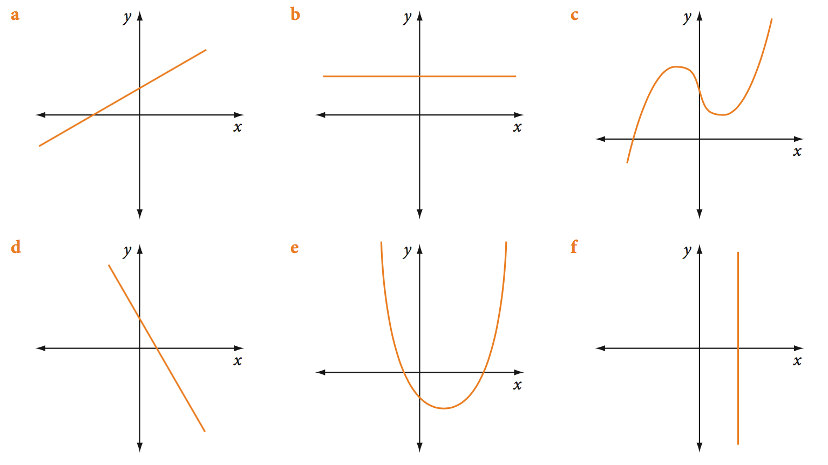
Question 5 3 marks

Look at the Cartesian plane below and write down the coordinates of the points A, B and C.

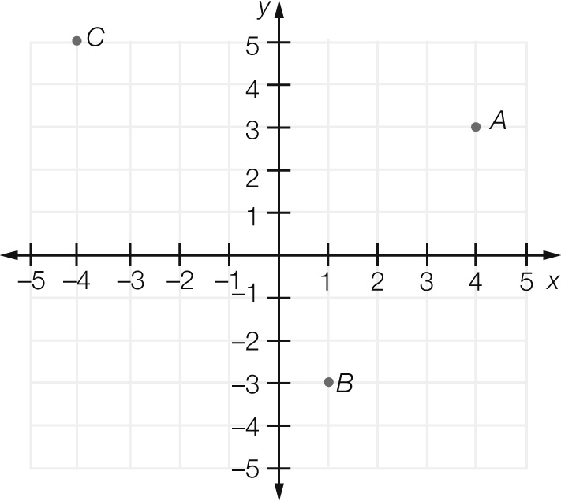
A ______________

B ______________

C ______________

Question 6 10 marks

Use the rule y = 3x + 1 to fill in the table below then plot as a linear graph

x | -3 | -2 | -1 | 0 | 1 | 2 | 3
y

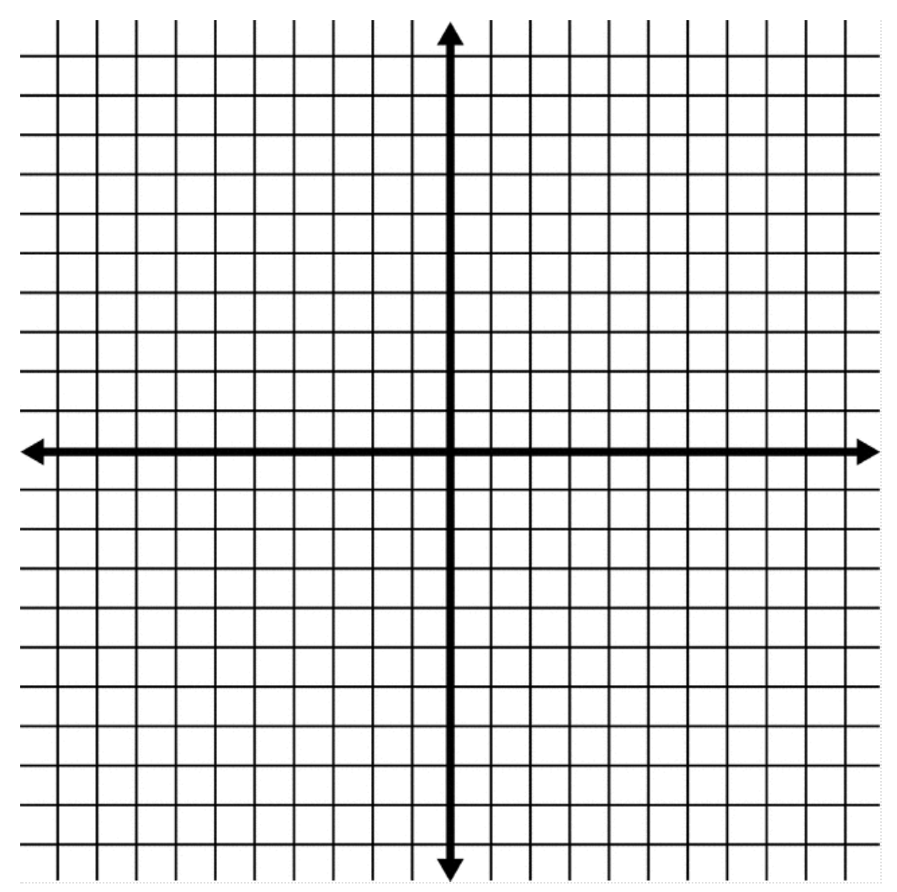

Question 7 2 marks

The x-coordinate of a point on the line y = 10 – 3x is 3. Write down the y-coordinate.

Question 8 4 marks

Find the rule for these tables of values.

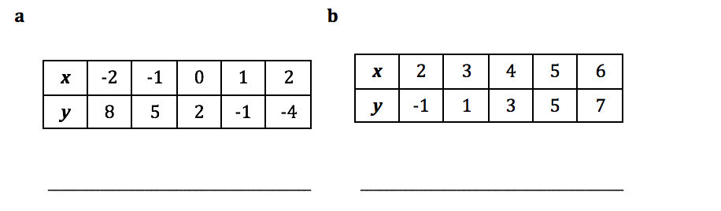

Question 9 4 marks

Write down the equation of each of the following lines.
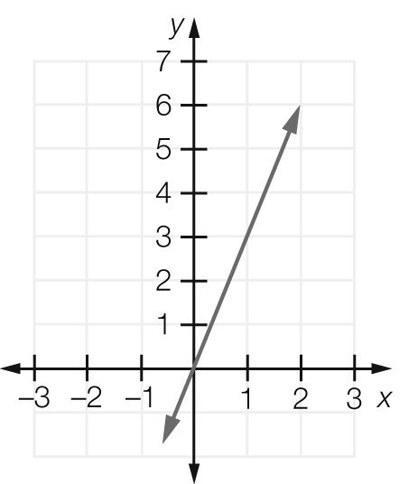
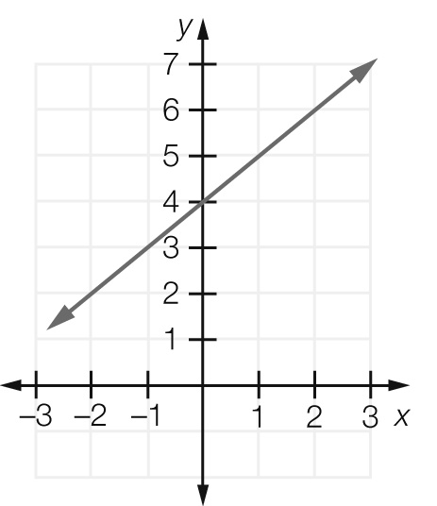
- b)

__________________ ___________________

Question 10 6 marks
The following shapes have been made with matchsticks

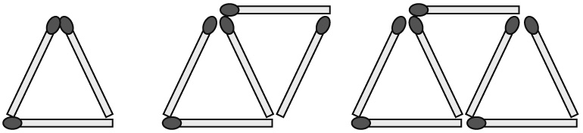

- Complete the table of values.

Number of triangles  (t) | Number of matches  (m)
1 | 3
2 | 5
3
4
5

- Graph each set of values and find the number of matches needed to build 20 triangles.

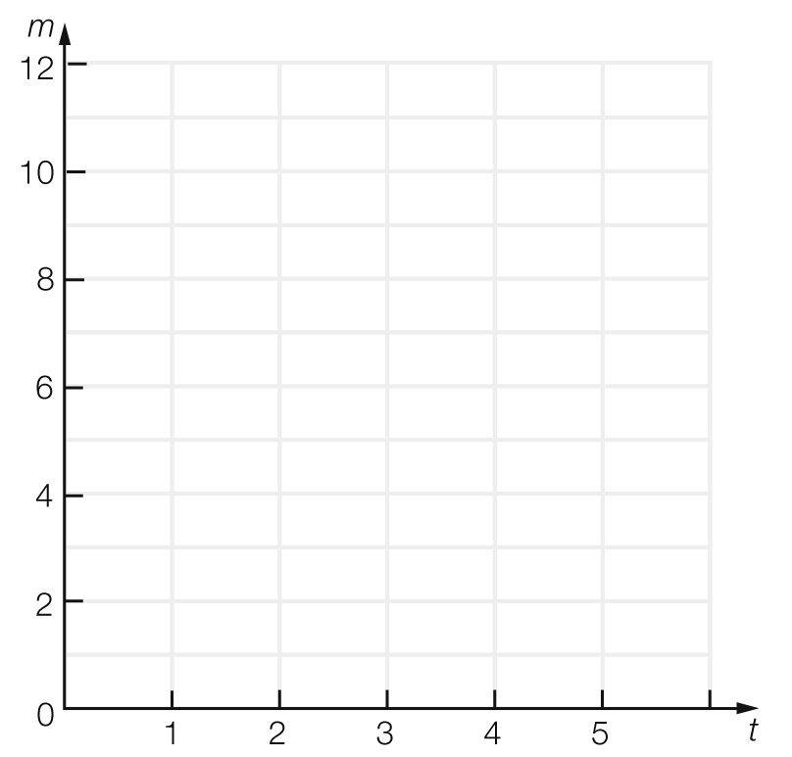

- Find the pattern, or rule, in terms of m and t.

Question 11 3 marks

A: A possible result.
B: All possible results.
C: An activity that involves chance.
D: Doing the activity.
E: A particular result.
F: Not a particular result.
______ Probability Experiment
______ Outcome
______ Sample Space
______ Event
______ Complement
______ Trial

Question 12 10 marks

The two-way table below shows the results of a poll conducted of a group of students who own mobile phones to see who pays their own bills.

 | Boys | Girls | Total
Pay own bill | 7 |  | 23
Do not pay own bill |  | 4
Total | 12 | 20

- Complete the above two-way table
- How many people participated in this poll?

- How many of the students surveyed did not pay their own bill?

- Find the probability that a randomly selected student:
- Is a girl who pays her own bill

- Does not pay their own bill

END OF TEST

